7.Draw a UML diagram for online purchasing system. Provide top level use cases for a
web customer making purchases online. Web customer actor uses some web site to
make purchases online. Top level use cases are View Items, Make Purchase and Client
Register.

AIM:

To design a UML diagram for an online purchasing system.

PROCEDURE:

Identify Actors:
- Web Customer: Browses and purchases items.
- Website: Manages inventory, orders, and customer details.
Define Use Cases:
- View available items.
- Make a purchase.
- Register as a client.
Create Diagrams:
- Use Case Diagram: Represents customer interactions with the online purchasing system.
DIAGRAMS:

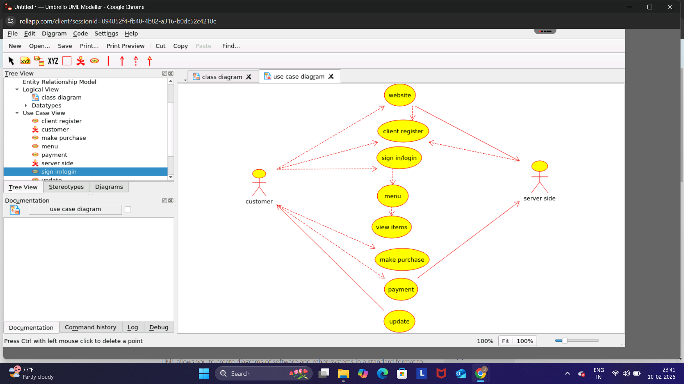

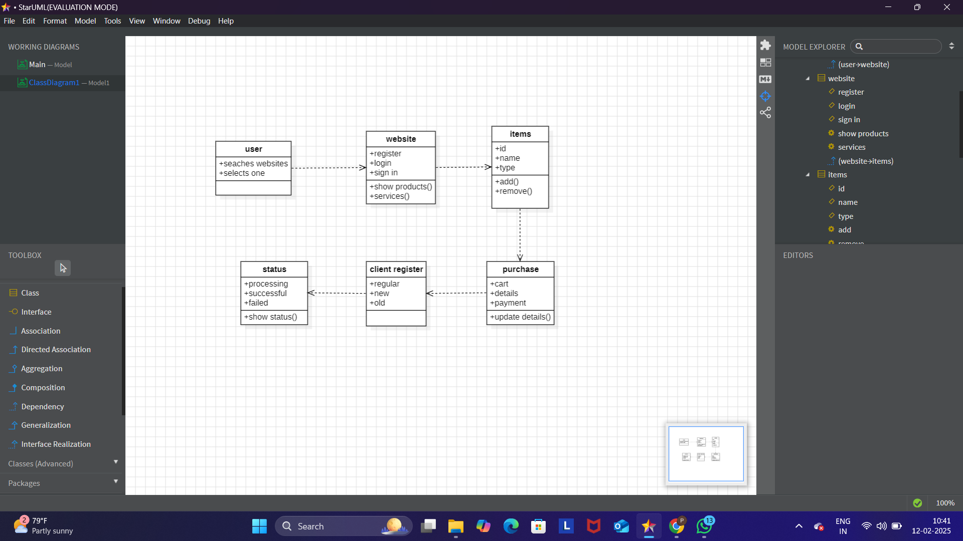

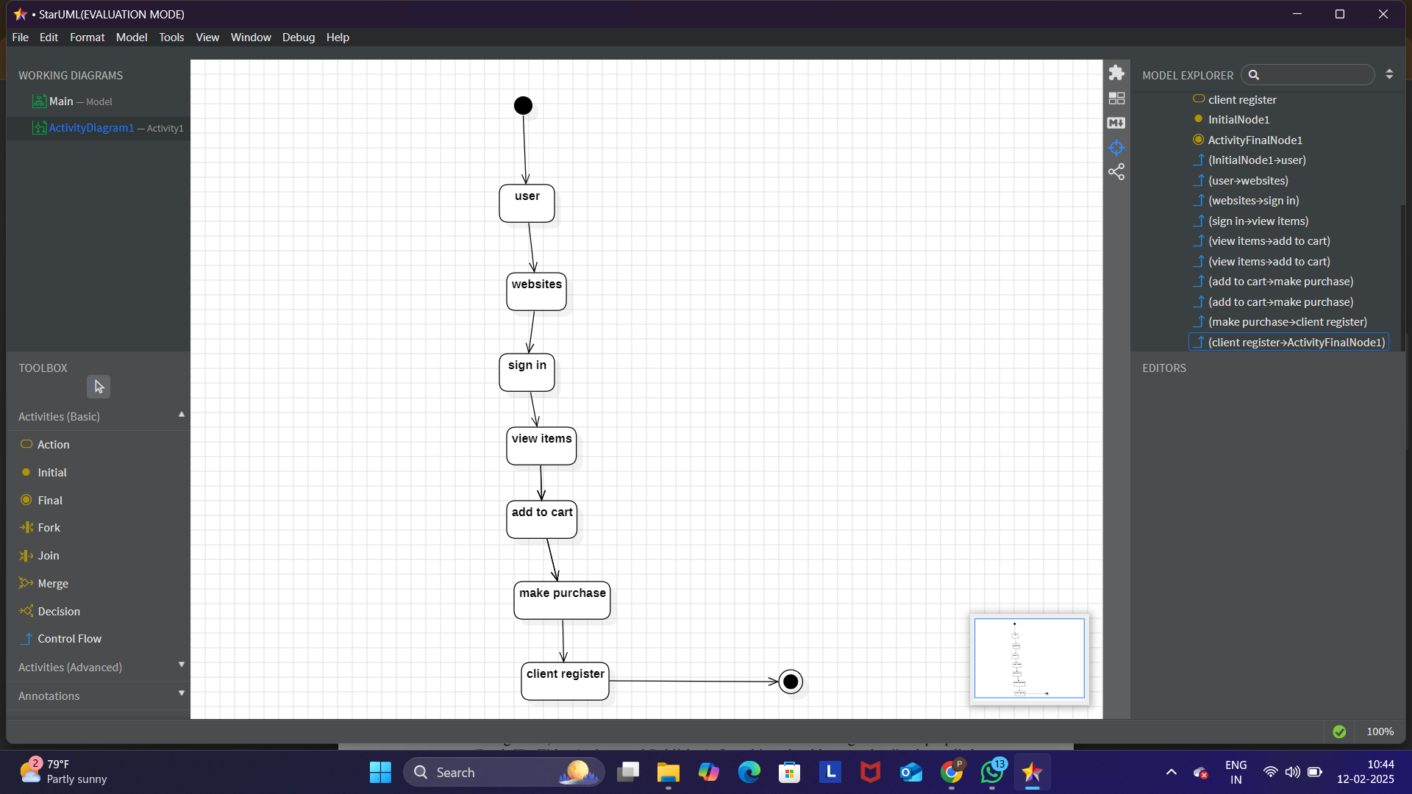

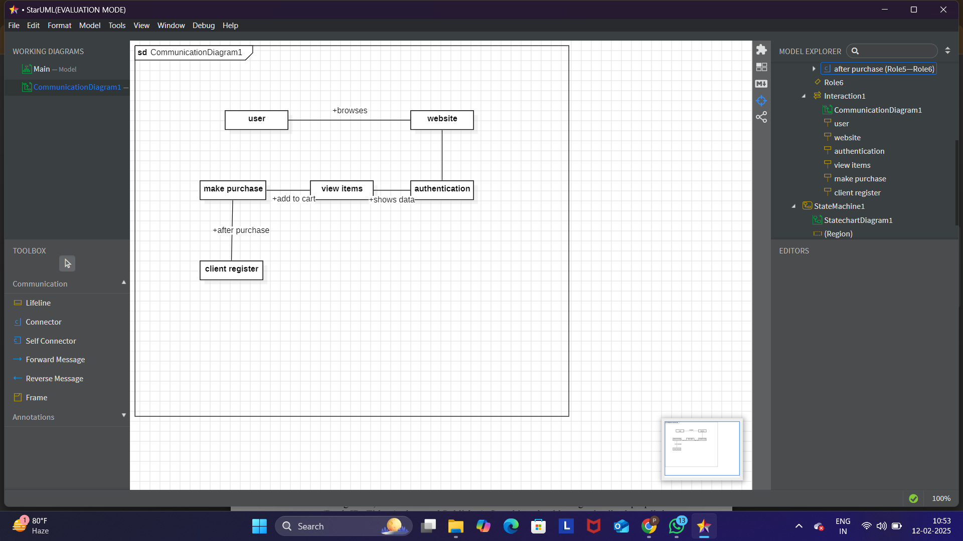

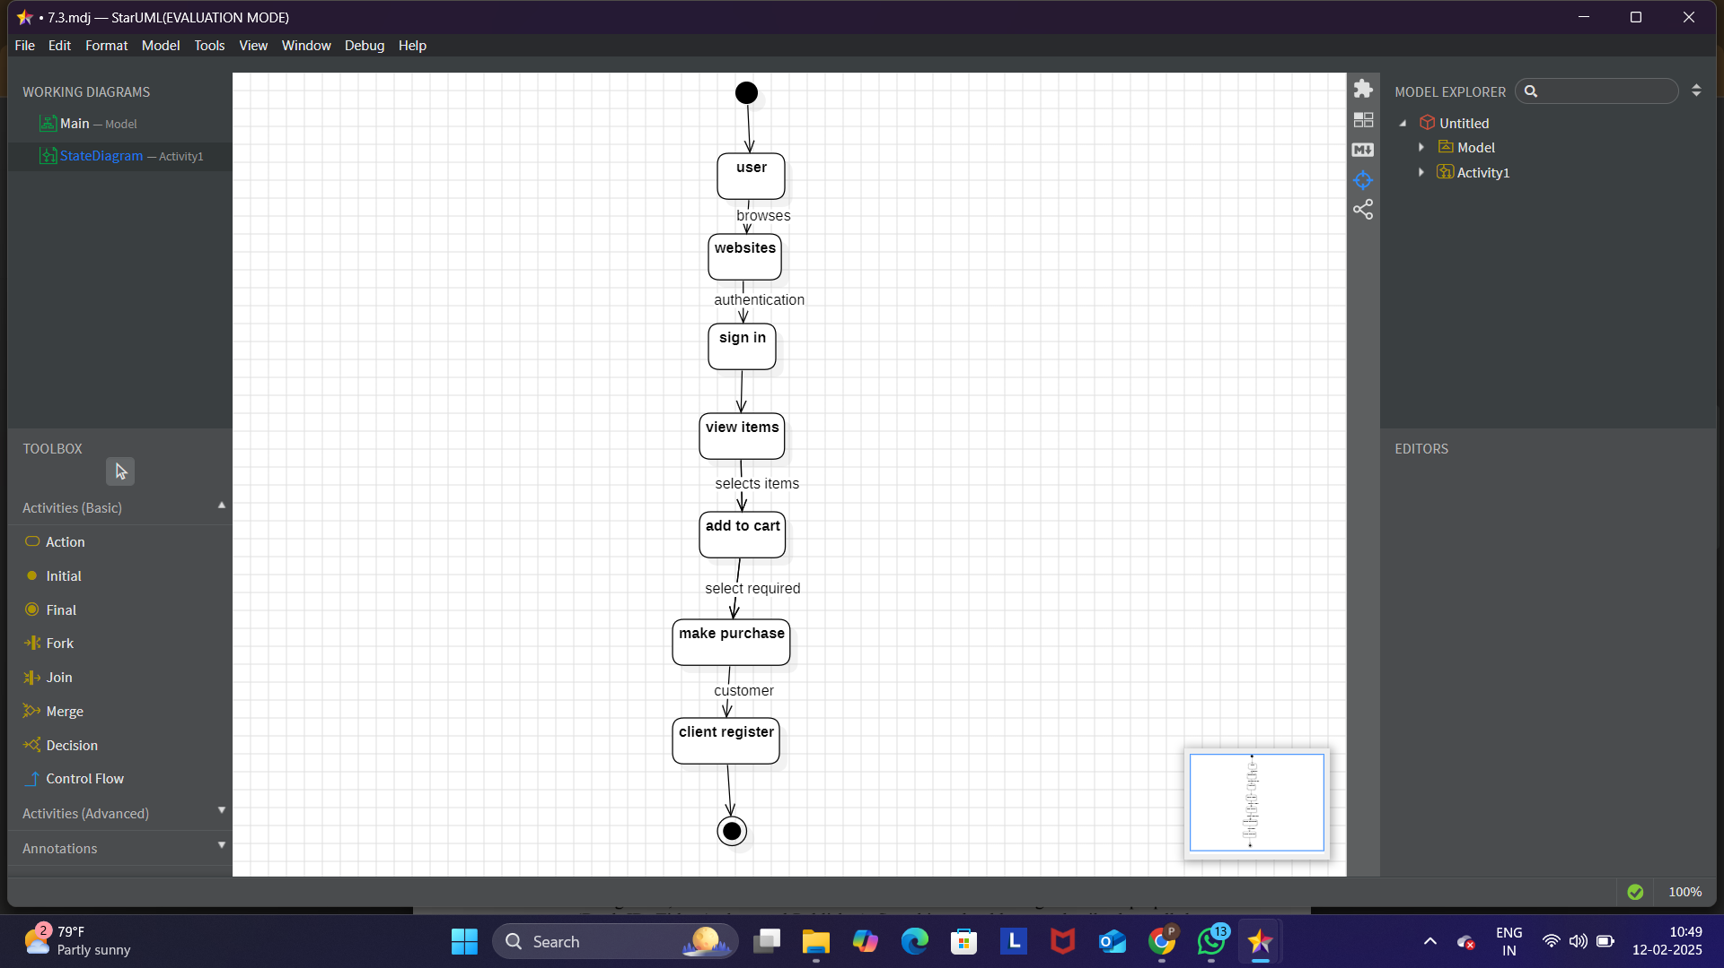

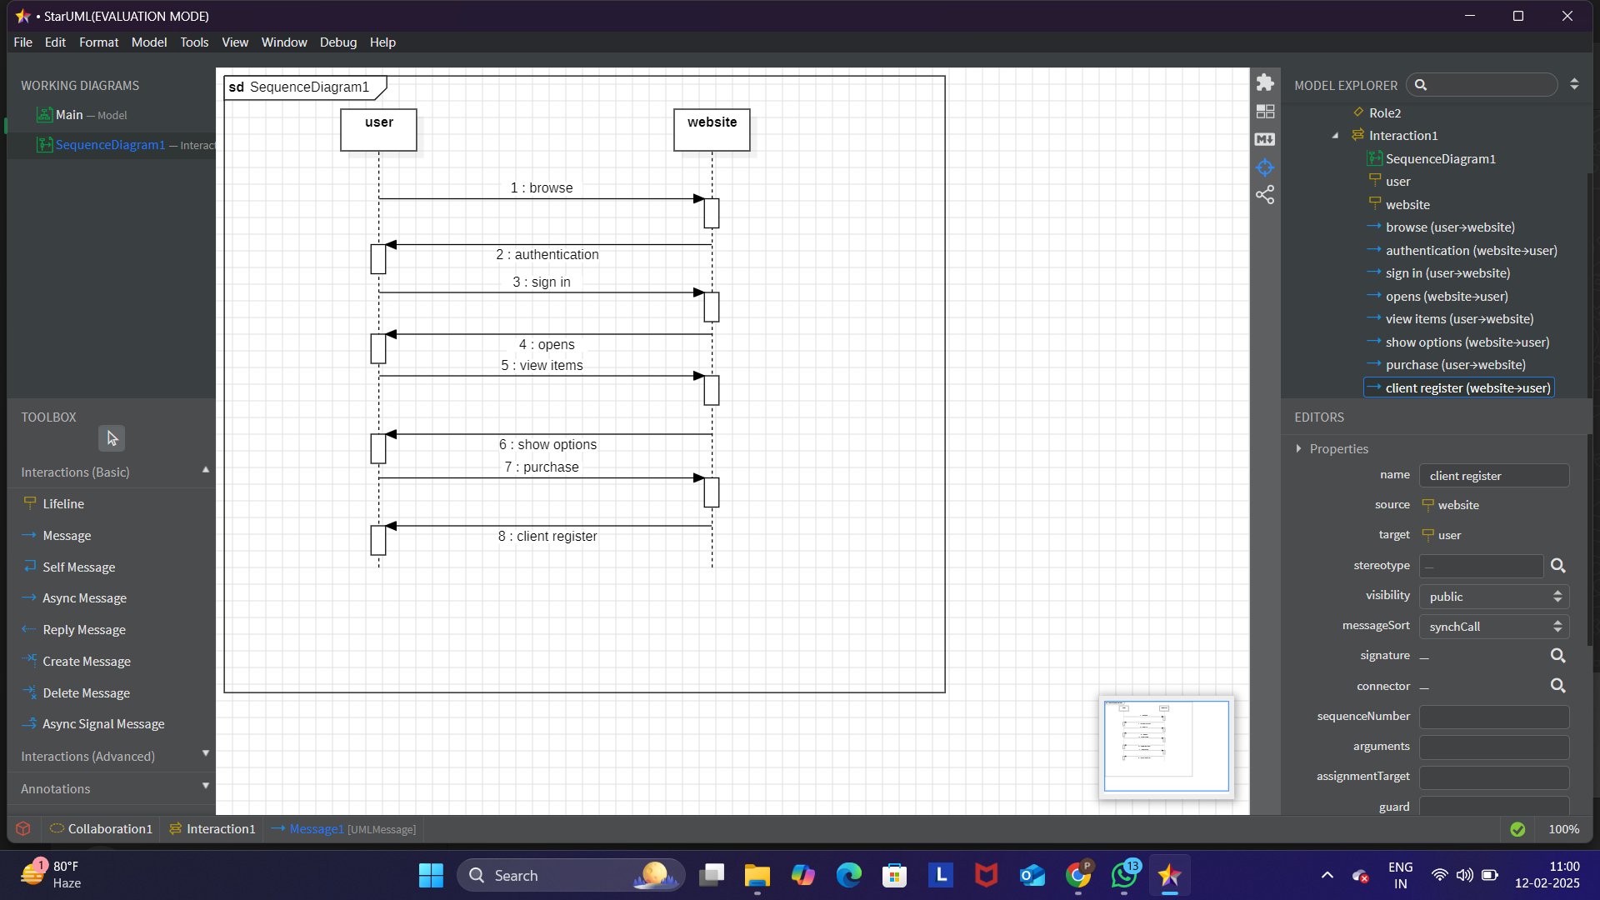

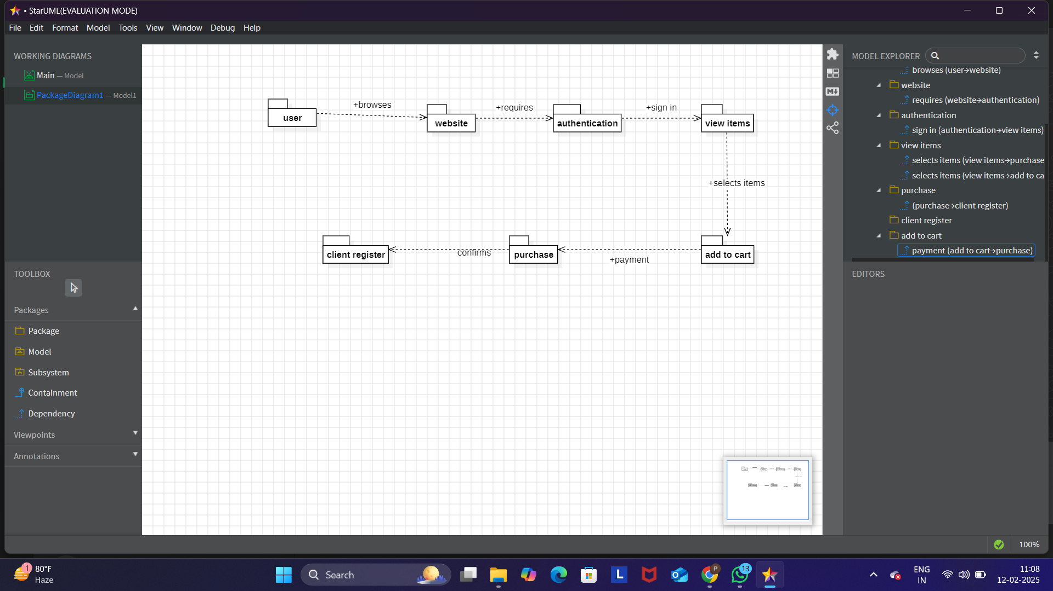

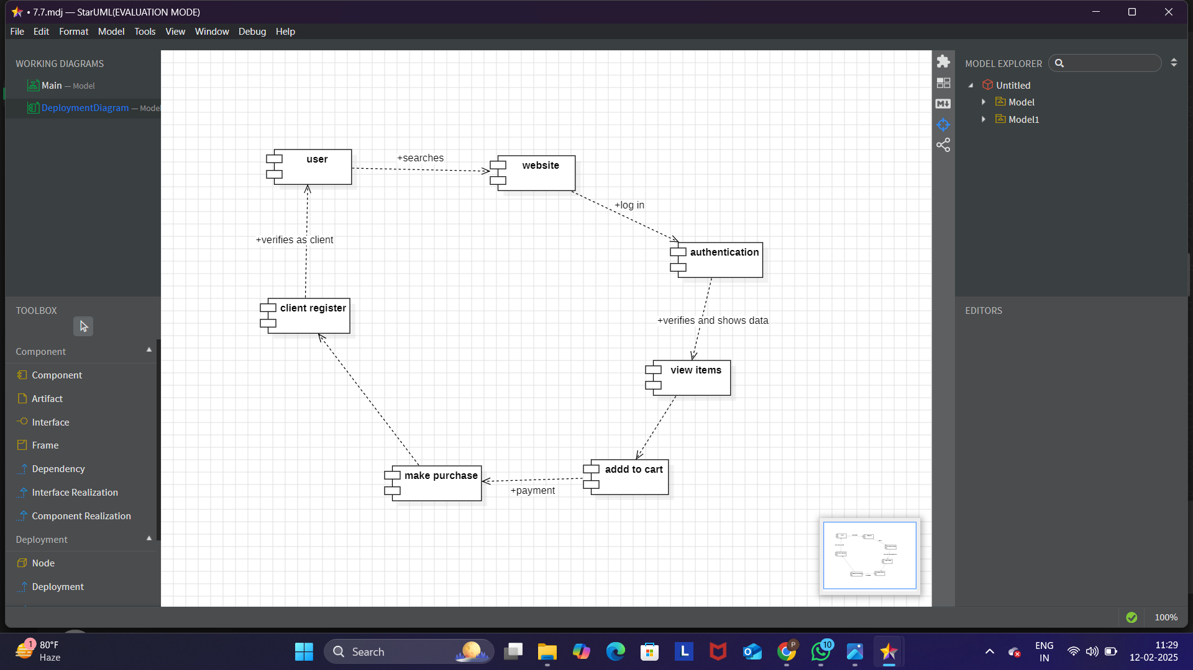

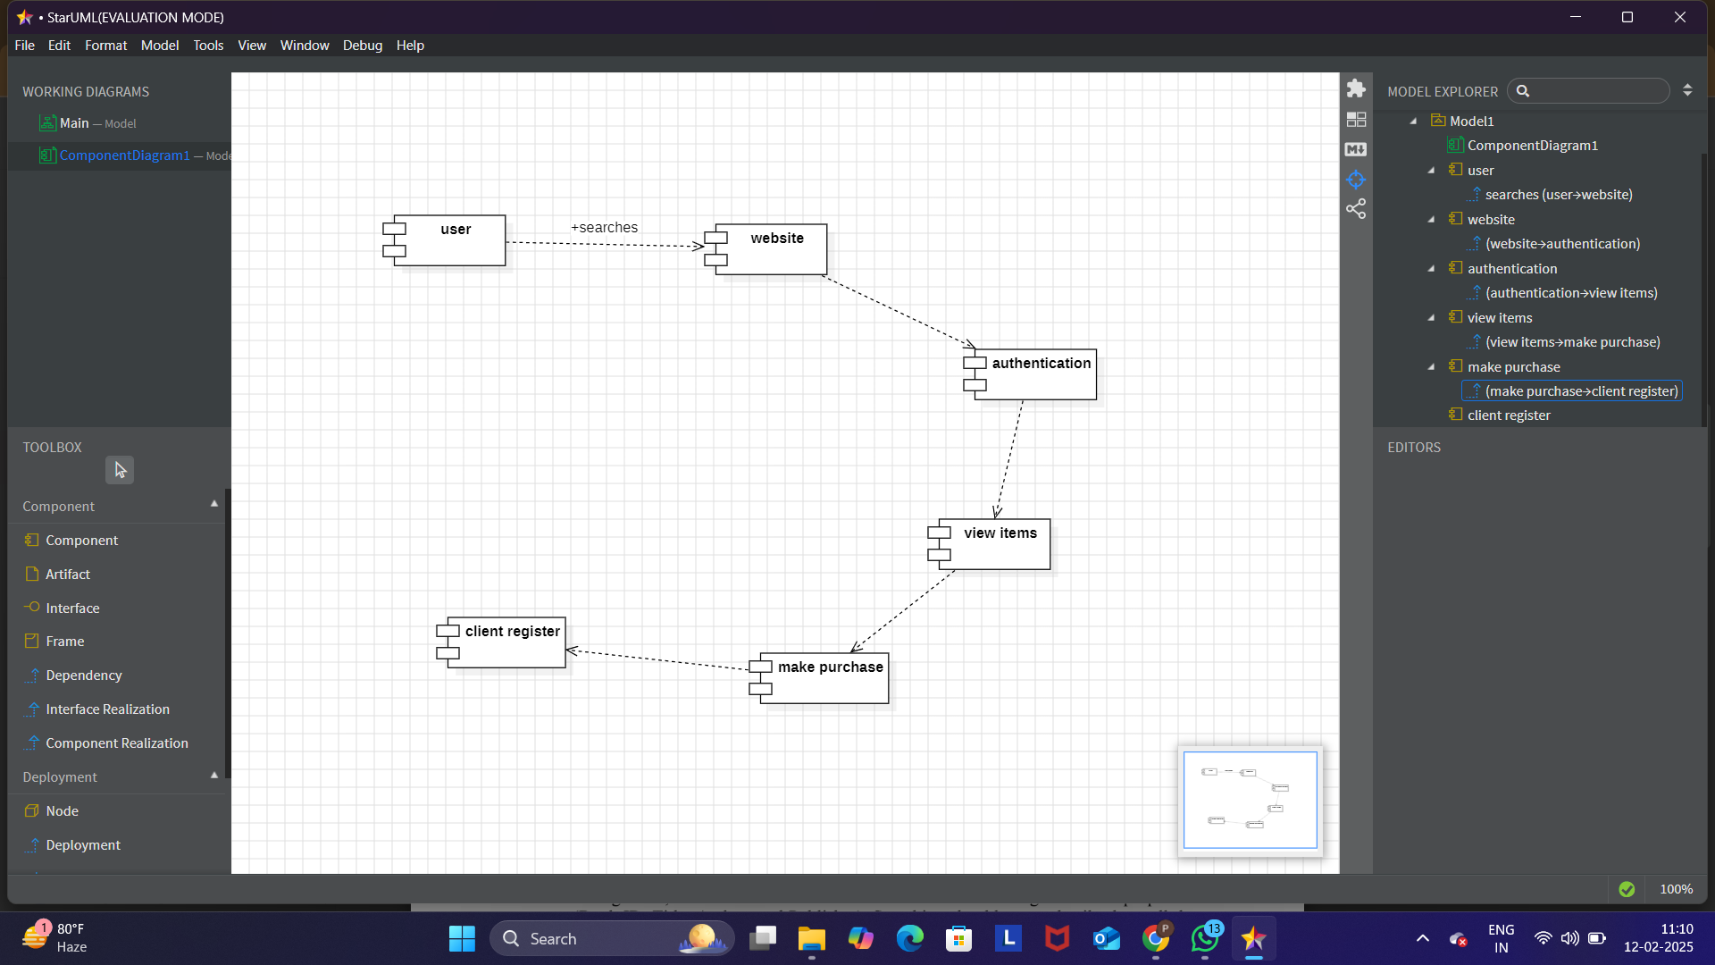

RESULT:

The UML diagram provides a structured representation of an e-commerce platform, ensuring clarity in the purchasing process.

